|  |  |  |
| --- | --- | --- |
| **Name:**  **Sumukh Raju Bhat** | **SRN: PES1UG19CS519** | **Section H** |
| **Date: 27/3/2022** | **Week Number:07** |

**Simple Calculator Web-app:**

**Description:**

A web application to mimic a simple calculator which can perform addition, subtraction, division and multiplication on two operands, built using Spring framework in Java.

**Dependencies:**

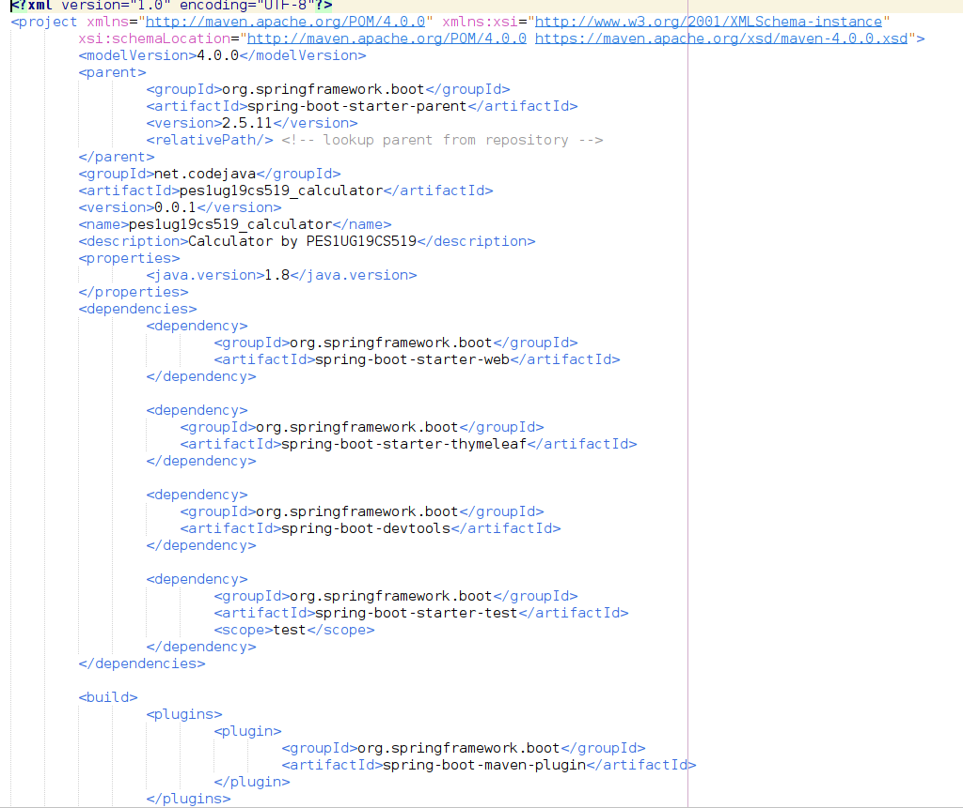

**Main code:**

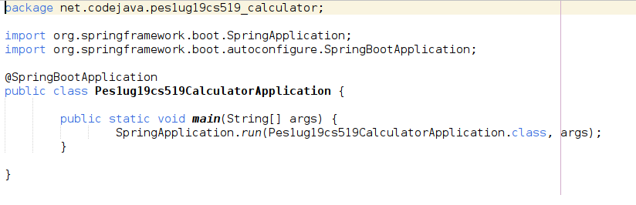

**Controller code with Model as parameter:**

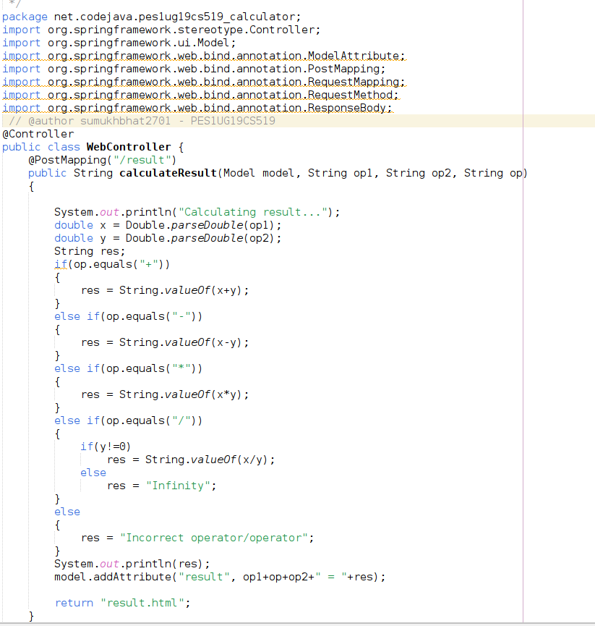

**HTML templates for view:**

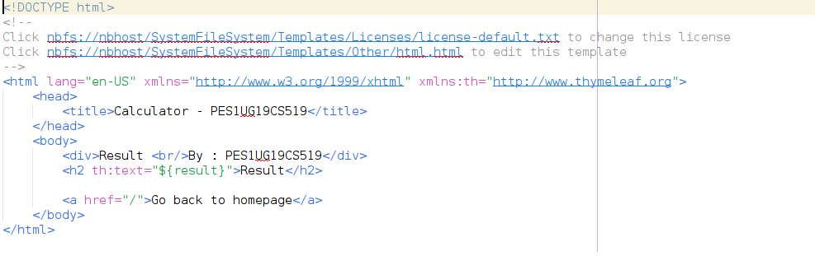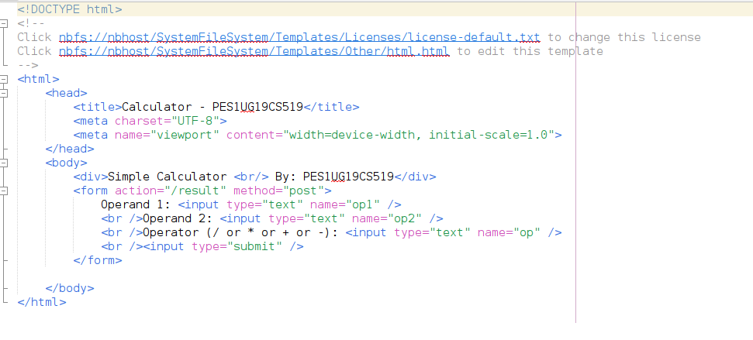

**Testcases:**

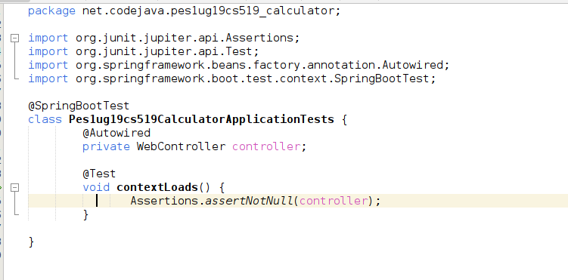

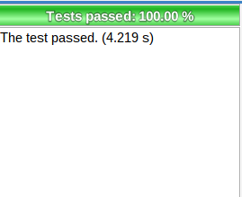

**Output screenshots:**

